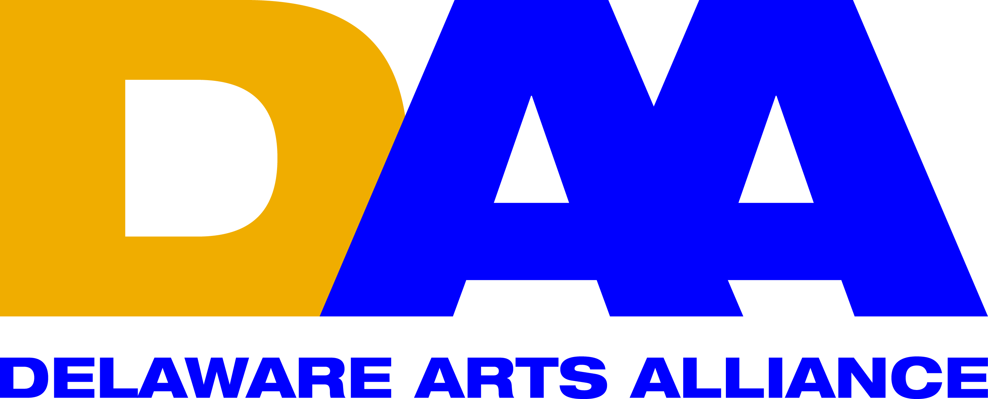 National Arts Advocacy Day 2015; Delaware Arts Alliance Report
Location & Date: | Omni Shoreham & Capitol Hill offices in Washington, D.C., Monday-Tuesday March 23-24, 2015
Who convened? | Americans for the Arts (AFTA)
Objective | To emphasize the importance of developing strong public policies and appropriating increased public funding for the arts.
Participants | A broad cross section of America's cultural and civic organizations, along with 550 grassroots advocates representing 48 states. Delegations from each state are coordinated by AFTA’s appointed State Arts Captains. DAA is Delaware’s State Arts Captain.
Topics addressed | - Sunday, March 22. State Arts Action Network (SAAN) meetings. SAAN members share recent activities and best practices. G. Gonzalez, DAA’s Executive Director, is currently the SAAN National Chair.  - Monday, March 23. Briefings & support materials on the National Endowment for the Arts (NEA), Arts in Education programs, and Charitable Giving were provided. Randy Cohen, AFTA Researcher, shared facts and figures to make the case for the arts. Dr. Jane Chu, NEA Chairman was the Keynote Speaker of the day. Breakout panels & advocacy role playing were part of that day’s activities. State delegations met and planned visits to the Hill for the next day.  - Tuesday, March 24. Visits to Capitol Hill. Delaware delegation meetings took place as follows:  - Sen. Coon’s office, 9:30 a.m. We talked to Scott Falin.  - Sen. Carper’s office, 11:00 a.m. We talked to Greg Hershman.  - Rep. carney’s office, 2;30 p.m. We talked to Elizabeth Connolly.
Delaware Delegation | - Joann Balingit/DE’s Poet Laureate & DAA member  - Melissa Grier/dancer & arts advocate  - Barbara Cairns/DE Symphony Orchestra  - George Meldrum/Nemours & DAA Board member  - Sheila Dean Ross/arts-education specialist & DE Division of the Arts staff  - JuneRose Futcher/photographer from Lewes & member of DAA Membership Committee  - G. Gonzalez/DAA Executive Director
Results | A few days after the delegation’s visit to Capitol Hill, Scott Falin, Legislative Aide to Sen. Coons, forwarded the two attached letters from the senator: (1) supporting increasing funding for the NEA and the National Endowment for the Humanities (NEH) in FY2016; (2) supporting increasing funding for the Office of Museum Services in FY2016.
Next Steps | Briefs provided by AFTA (also attached) indicate Sen. Coons, Sen. Carper, and Rep. Carney’s arts related voting records. Based on results (covered above), there are areas of opportunity:  - Sen. Coons: First thanking him for his support for the NEA & Office of Museum Services, and then ask 1) for support of the reauthorization of the Elementary & Secondary Education Act (ESEA) and increase equitable access to arts education; 2) to protect the full value & scope of the charitable deduction in all forms of charitable gifts; 3) to join the Senate Cultural Caucus.  - Sen. Carper: 1) ask to support funds for the NEA at $155 million (above President Obama’s request of $149 million FY2015) in the letter circulated by Sen. Tom Udall (D-NM); 2) ask for the support of the reauthorization of the Elementary & Secondary Education Act (ESEA) and increase equitable access to arts education; 3) ask to protect the full value & scope of the charitable deduction in all forms of charitable gifts; 4) ask to join the Senate Cultural Caucus.  - Rep. Carney: 1) ask to support funds for the NEA at $155 million (above President Obama’s request of $149 million FY2015) in the letter circulated by Sen. Tom Udall (D-NM); 2) ask for the support of the reauthorization of the Elementary & Secondary Education Act (ESEA) and increase equitable access to arts education; 3) ask to protect the full value & scope of the charitable deduction in all forms of charitable gifts; 4) ask to join the House STEAM and Art Caucuses.

