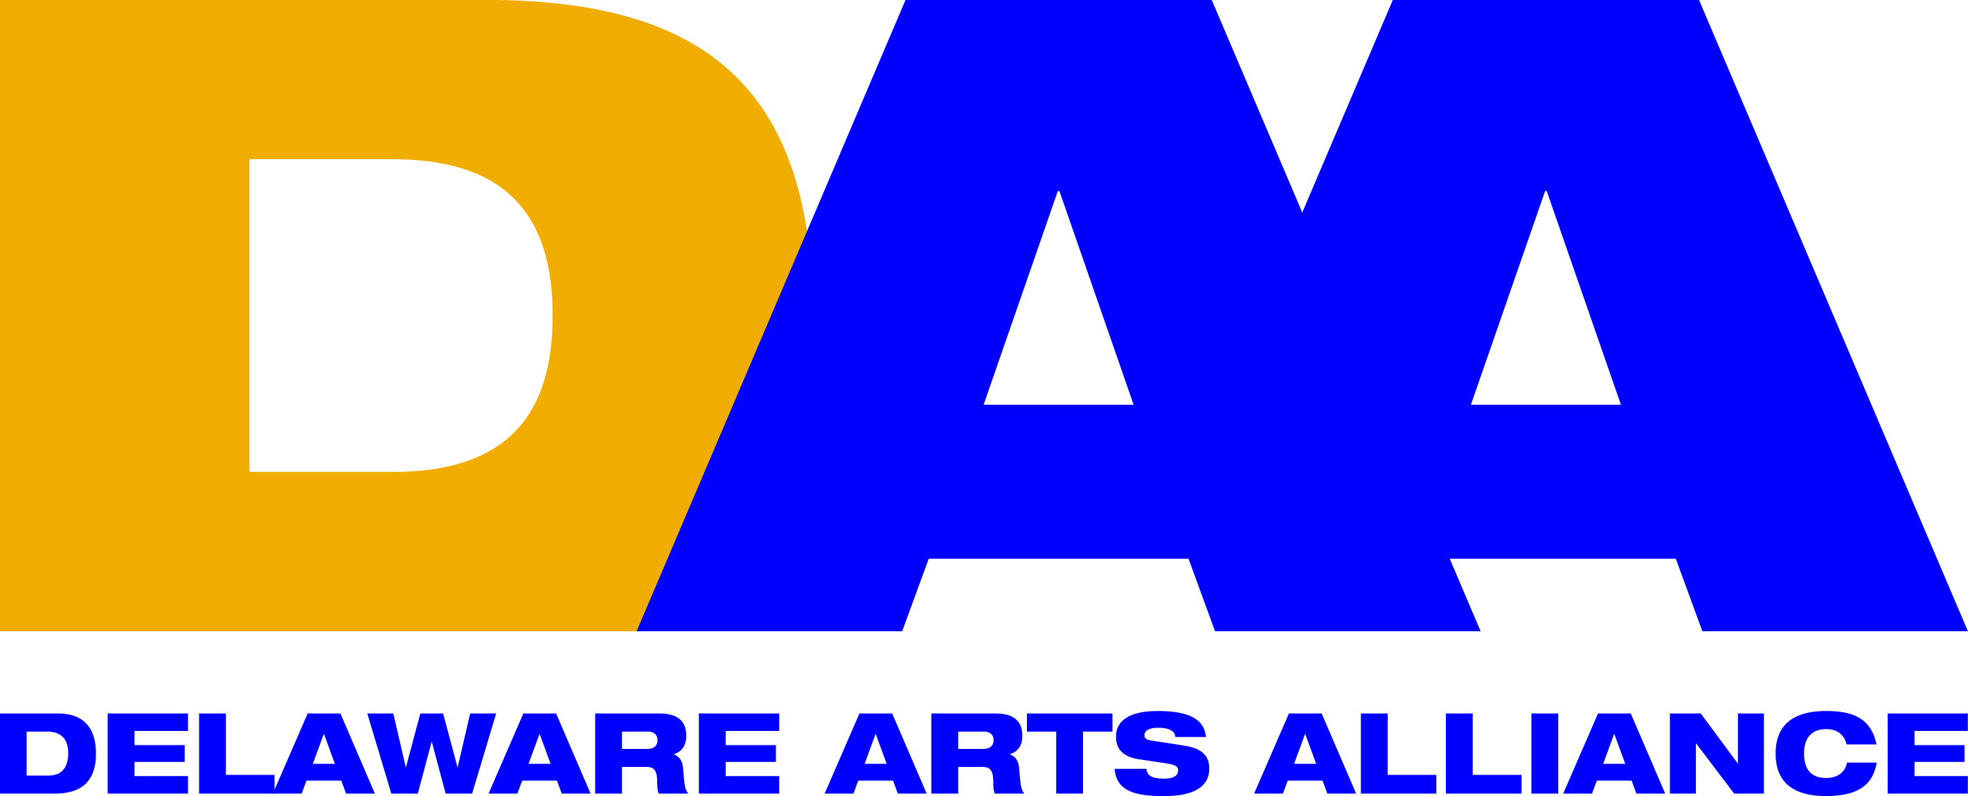 FOR IMMEDIATE RELEASE April 7, 2016
CONTACT: Lynn Calder
lcalder@DelawareArtsAlliance.org
(302) 468-4841

Delaware Arts Alliance will present “Arts Advocacy in the Digital Age” at DAA Arts Rendezvous in Sussex County program at Possum Point Players April 8

Wilmington, DE (April 7, 2016) -- Delaware Arts Alliance (DAA) Executive Director Guillermina Gonzalez announced that DAA will hold an arts advocacy event, Arts Rendezvous in Sussex County, on Friday, April 8 from 4:00 pm to 6:00 pm at Possum Point Players in Georgetown, Delaware.

The program will feature a presentation, “Arts Advocacy in the Digital Age”, by DAA Board Member George Meldrum and DAA Operations Specialist Jessica Ball. The program is open to the public and all are invited to attend.
Dr. Gonzalez stated, “Arts advocacy in this pivotal electoral year is taking on new importance as Delaware faces a change in leadership at the national and gubernatorial levels. Technology, such as DAA’s VoterVoice software, keeps advocates informed and engaged on policy issues and candidates’ position on the arts.”

Arts Rendezvous in Sussex County is part of a series of DAA learning and networking events for Kent, New Castle, and Sussex Counties to educate and engage the arts community while creating a strong base of advocates through DAA’s Free Individual Membership Campaign.

DAA Board Member George Meldrum is the Senior Advisor for Governmental & Community Affairs and a Registered Lobbyist for the Nemours Foundation. He serves on the Executive Council of AARP, the boards of the Delaware Children’s Museum, Common Cause of Delaware, and the American Civil Liberties Union. George has a BA in history and international relations from the University of Delaware and a MA in psychology from Washington College.

DAA’s Operations Specialist Jessica Ball is a 2013 graduate from the University of Pennsylvania’s School of Design with dual Masters Degrees in Historic Preservation and Landscape Architecture & Regional Planning and holds a Bachelor’s degree in Architecture from Florida International University. Jessica’s interdisciplinary knowledge allows her to be an effective advocate for the arts, design, and culture.

Arts Rendezvous in Sussex County is $5 for DAA members and $10 for non-members (payable at the door). Light fare will be served and advance reservations are recommended. Please rsvp to jball@delawareartsalliance.org to attend by April 7. Possum Point Players is located at 441 Old Laurel Road
Georgetown, Delaware. DAA is proud to count the Delaware Division of the Arts among its supporters.

The Delaware Arts Alliance is the unifying voice for the arts and arts education throughout the state, advocating for the central role of the arts in advancing dynamic communities and a creative citizenry. DAA firmly believe that a strong creative culture enhances education, the economy, and civic life. Since its founding in 2009, the Alliance has made presentations to the Joint Finance Committee of the Delaware legislature, hosted speaking events, and organized advocacy programs throughout the state. For more information, please visit www.delawareartsalliance.org.
###

