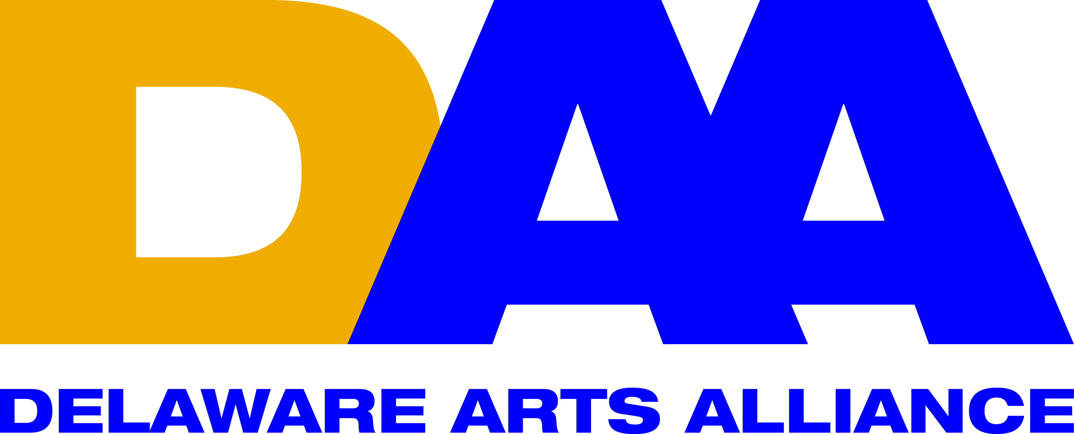 Arts Education Partnership; State Policy Symposium.
Delaware Arts Alliance Report
Location & date: | Capital Hilton, Washington, D.C., Saturday March 21, 2015
Who convened? | Arts Education Partnership (AEP), a part of Council of Chief State School Officers (CCSSO).  AEP is a national network of organizations dedicated to advancing arts in education through research, policy & practice. It cooperates with the National Assembly of State Arts Agencies (NASAA) and in agreement with the National Endowment for the Arts (NEA) and the U.S. Department of Education.  The event is sponsored by Americans for the Arts (AFTA) & The Kennedy Center.
Objective | AEP intends to instill high quality education in and through the arts.
Participants | 150+ arts education advocates from across the nation.  DAA tweeted from the location with #aepsymp
Topics addressed | Agenda covered the following topics:  - Federal education priorities and how arts and education leaders are prepared to respond.  Main message: the Elementary and Secondary Education Act (ESEA) is long overdue. Need to continue pushing its authorization.  - State efforts to prepare all students to be ready for college, careers, and citizenship & pathways for creative careers.  Note: Lillian Lowery, former Secretary of the Delaware Department of Education, participated in this panel now as Superintendent of Schools, Maryland Department of Education.  Main message: the arts open up possibilities for career advancement. There is a need for clear “actionable data” on the arts education front. Questions to address include: What are the high quality creative careers? How can state and local arts education leaders form partnerships with the employer community to support creative careers? What are some of the policies, programs, and incentives that connect students to creative careers?  - Briefing on new federal research on the Arts in Education. Recent data provided by NEA’s Office of Research & Analysis.  - Linking state and local efforts for expanded access to quality arts education  Main message: how to select pertinent partners in each state to be effective when resources are limited? “Power Mapping” was suggested as a tool to select key education operators. Worth evaluating: Brookings Institution’s March 2015 “Measuring and Understanding Education Advocacy”. This research evaluates if advocacy efforts have succeeded in influencing the public policy that governs education.
Connection to Delaware | The link below provides details on Delaware State Art Education Policies. Notably, no art education surveys have been conducted in the state so far that identify “actionable data”. Link: http://www.aep-arts.org/wp-content/DatabaseSupport/StatePolicyReport_SPR_PopWindow.php?pstate=delaware
Next Steps | 1) Identify Delaware’s KEY Education stakeholders, potentially applying “Power Mapping”. Alternative tools to detect Key holders should be considered.  2) Construct an arts-education advocacy agenda including KEY stakeholders. Coalition building should be a natural outcome of this phase.  3) Defining measurable advocacy outcomes is pivotal for arts advocates led by DAA. As a consequence, we will achieve increasing levels of influence to instill policy change.

