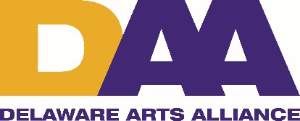

Arts Rendezvous Meet the Candidates Worksheet and Program Continuity

Location: MOT Charter High School, 1275 Cedar Lane Road, Middletown, DE 19709
Start Time: 5:00 pm
Date: Tuesday, July 26, 2016
Speakers/Participants:
Elaine Elston, Principle of MOT Charter High School
Dr. Guillermina Gonzalez, Executive Director, Delaware Arts Alliance
Candidates for Lieutenant Governor
Brad Eaby (D)
Gregory Fuller (D)
La Mar Gunn (R)
Bethant Hall-Long (D)
Kathy McGuiness (D)
Ciro Poppiti (D)
Sherry Dorsey Walker (D)

Materials and supplies: 6 chairs for speakers, mic, podium, projector, screen and laptop
Food: Coffee, cookies, water

Program Agenda:
5:00 Program begins with some mingling time
5:10 Welcome: Elaine Elston and Dr. Guillermina Gonzalez
5:15 Explanation of program and DAA. Introduction of Candidates: Dr. Guillermina Gonzalez, Executive Director, Delaware Arts Alliance
5:20 Candidates for Lieutenant Governor speak about the arts and arts education for 2 to 3 minutes (alphabetical order):

Brad Eaby (D)
La Mar Gunn (R)
Kathy McGuiness (D)
Ciro Poppiti (D)
Sherry Dorsey Walker (D)

5:45 Floor open for questions
6:00 Program conclusion, thank yous and invitation to mingle and network: Dr. Guillermina Gonzalez

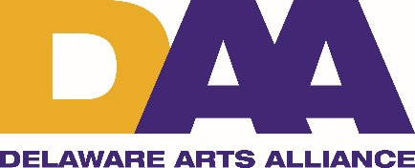

Here are some significant ways that the arts impact Delaware’s culture and economy:

The Arts Mean Business: A Strong Sector in Delaware’s Economy:
- The arts represent a $142.3 million industry in Delaware.
- The arts are among Delaware’s top 10 employers, supporting 3,868 full time jobs.
- The arts generate $9.9 million dollars in local and state revenue.
- The arts return nearly 2.5% on investment (with the current State Arts Budget).
- The arts create attendee spending of an average of $29.80/person beyond admission cost.
- The arts cultivate an entrepreneurial environment.

The Arts Mean Impact in Education: Creating a Future Workforce with a Resourceful Advantage:
- Delaware is a national leader given the recently approved Arts-Education K-12 state standards.
- New Delaware standards deepen students' cognitive skills and position them for career success.
- 63% of Delaware K-12 Arts Educators created and led this effort.

DAA’s Priorities for the Coming Year:
- Support state funding for the arts in Delaware in FY2017 at $3.4 million. This represents $3.51 per capita in state funding for the arts, making Delaware 3rd in the nation.
- Make the First State truly first in per capita state funding for the arts by 2020, by increasing the state budget for the arts over three years to $6.25 per capita, or $5.6 million. That's less than a $1/person/year increase!
- Promote county and municipal matching of state funding support for the arts institutions in the districts.
- Support federal funding for the arts in FY2017 at $149.8 million. Delaware receives more than $700,000 annually for arts programming.
- Establish three Creative Districts by 2018 (one in each County). To facilitate the process; real estate taxes are waived for 5 years; a 10-year income tax abatement is applied for all creatives/artists on their pieces/products sold in the district for 10 years.
- Fund statewide research to assess the impacts of the arts as a pivotal part of a comprehensive education and competitive economy.
- Support and preserve the Visual & Performing Arts leadership role at the Delaware Department of Education.

