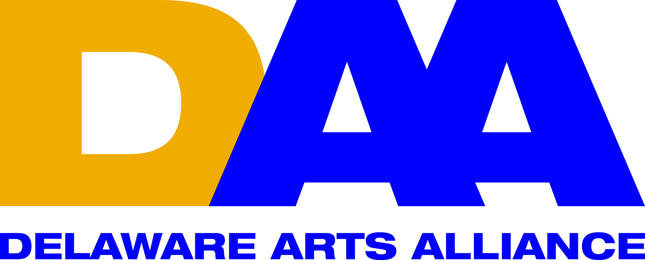 FOR IMMEDIATE RELEASE September 7, 2016
CONTACT: Lynn Calder
lcalder@DelawareArtsAlliance.org
mobile: (302) 540-5796

Delaware Arts Alliance’s Arts Rendezvous to Feature Candidates
for Governor to Discuss the Arts on September 8 in Dover

Wilmington, DE (September 7, 2016) -- Delaware Arts Alliance (DAA) Executive Director Dr. Guillermina Gonzalez announced DAA’s Arts Rendezvous program in Kent County on Thursday, September 8 at 5 pm at the Old State House in Dover. The program will bring together candidates in the electoral race for Governor to engage with arts advocates and voters. The discussion topic will be the impact of the arts on Delaware’s economy and the value of arts education.

Candidates will have 2-3 minutes each to state their positions related to arts and economic development and arts education. To date, the following representatives and candidate for Governor have agreed to appear: State Senator Colin Bonini (R), Cerron Cade, on behalf of Representative John Carney (D), and Martin Nicholson, on behalf of Lacey Lafferty (R). Green Party Candidate Andrew Groff has provided a statement.

Dr. Gonzalez shared her thoughts on the program, “The arts play a critical role in Delaware’s economy and culture, and annually provide $9.9 million in local and state revenue. The arts and arts education also help shape a future innovative workforce for the state. Arts Rendezvous will give the candidates for Governor an opportunity to share their vision for the role and impact of the arts in Delaware. ”

Arts Rendezvous is part of a series of DAA learning and networking events for Kent, New Castle, and Sussex Counties to educate and engage the arts community while creating a strong base of advocates through DAA’s Free Individual Membership Campaign.

Because 2016 is an important election year, DAA is not charging its usual admission fee for Arts Rendezvous. Light refreshments will be served. The Old State House is located at 25 The Green, Dover, DE 19901. To rsvp, please contact Jessica Ball at jball@delawarwartsalliance.org. DAA is proud to count the Delaware Division of the Arts among its supporters.

The Delaware Arts Alliance is the unifying voice for the arts and arts education throughout the state, advocating for the central role of the arts in advancing dynamic communities and a creative citizenry. DAA believes a strong creative culture enhances education, the economy, and civic life. Since 2009, the Alliance has made presentations to the Joint Finance Committee of the Delaware legislature, hosted speaking events, and organized advocacy programs throughout the state. For more information, please visit www.delawareartsalliance.org.
###

