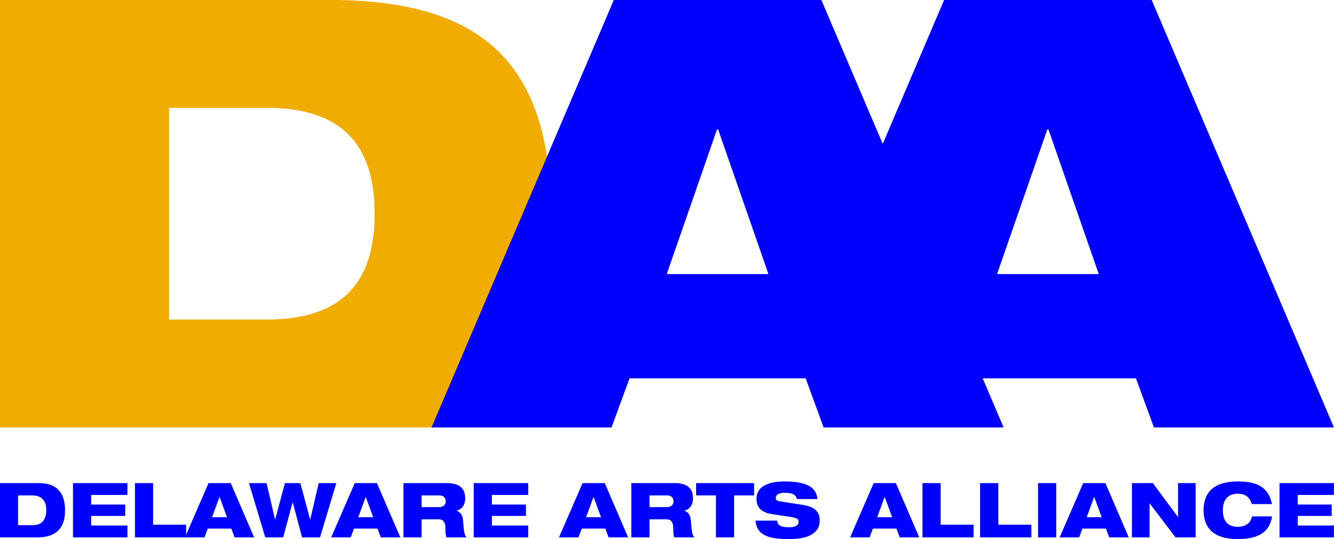 FOR IMMEDIATE RELEASE September 13, 2016
CONTACT: Lynn Calder
lcalder@DelawareArtsAlliance.org
(302) 468-4841

Delaware Arts Alliance announces inaugural Delaware Arts Advocacy Awards in partnership with the University of Delaware and the Delaware Division of the Arts October 10.

Wilmington, DE (September 13, 2016) – Delaware Arts Alliance (DAA) Executive Director Dr. Guillermina Gonzalez, in collaboration with the University of Delaware and the Delaware Division of the Arts, has announced the inaugural Arts Advocacy Awards to recognize champions of arts in the state. A celebration to honor the awardees will be held 7-9 p.m., Monday, October 10 at Mitchell Hall on UD’s Newark campus. The event is free and open to the public.

A selection panel of members of the DAA and members of the Delaware State Arts Council reviewed outstanding nominations for the awards in July. The nominating categories included:

- Education – an individual who has advanced arts education with an arts organization, project or program that supports lifelong learning in the arts (i.e., from early childhood to senior adults);
- Leadership – a board member or community leader that has been instrumental in guiding the business of an arts organization, project or program toward long-term strength and sustainability;
- Philanthropy – an individual whose selfless generosity in financial support or fundraising expertise has been essential to the long-term sustainability of an arts organization, project or program (note: impact of support is more important than actual dollar amounts); and
- Volunteerism – an individual whose contribution of time or talent to an arts organization, project or program has rendered invaluable service to the arts.

Nominees for awards included: Joann Balingit (Leadership); Lisa Bartoli (Leadership); Joann Browning (Education); Dori Connor (Education); Marcia DeWitt (Leadership); Xiang Gao (Leadership); Robert Grenfell (Education, Leadership); James Hartzell (Leadership, Philanthropy, Volunteerism); Nancy Lynch (Leadership, Volunteerism); Lynette Overby (Education); Skip Pennella (Leadership); Maria Ruffin (Education, Leadership, Philanthropy, and Volunteerism); Susan Salkin (Volunteerism); Johanna Schloss (Education); John Schoonover (Philanthropy); and Robert Stoddard (Education).

Delaware Division of the Arts Director Paul Weagraff commented on the panel’s review process for the nominations. “The panelists reviewed the nominations in advance and then convened to identify exemplary candidates in each category,” said Weagraff. “This was an extremely arduous task, as all the nominees demonstrated outstanding contributions in their respective arenas. The panelists came away from this process inspired by how these individuals all represent the best of what it means to be advocates for the arts.”

Dr. Gonzalez said of the inauguration and significance of the awards, “DAA is pleased to present the first-ever Arts Advocacy Awards. By recognizing the contributions of those individuals whose work and time support our arts community, we will demonstrate the vital impact of the arts statewide. We are fortunate to have so many talented and dedicated leaders of the arts statewide.”

George Watson, dean of UD’s College of Arts and Sciences (CAS), and Troy Richards, interim associate dean of the arts in CAS, noted the importance of the arts and culture scene to higher education.

“We are fortunate to partner with the DAA and Delaware Division of the Arts to recognize outstanding advocates for the arts in our state,” said Watson. “Bringing events like this to campus gives us the opportunity to generate a vital discourse on the contributions of the arts to our communities, and the mutual benefits we gain by working together.”

Added Richards, “The arts are a critically important avenue to help us engage students and audiences alike. We honor and support the artists, educators and leaders who represent the best of our arts community, and are grateful for the chance to illustrate for our students the power of art to connect communities.”

The program will also include performances by artists representing New Castle, Kent and Sussex Counties: Vocal Point (a co-ed a capella group at the University of Delaware); Sankofa African Dance Company (comprised of students from Inner City Dover and Central Delaware); and Anne Colwell and James Keegan (literary/theatre artists from Milton, DE who are also faculty members in UD’s Associate in Arts Program in Georgetown).

Tickets can be reserved at http://deartsadvocacyawards.eventbrite.com. More event details may be found on the DAA website.

The Delaware Arts Alliance is the unifying voice for the arts and arts education throughout the state, advocating for the central role of the arts in advancing dynamic communities and a creative citizenry. DAA firmly believes that a strong creative culture enhances education, the economy, and civic life. Since its founding in 2009, the Alliance has made presentations to the Joint Finance Committee of the Delaware legislature, hosted speaking events, and organized advocacy programs throughout the state. For more information, please visit www.delawareartsalliance.org.

###

