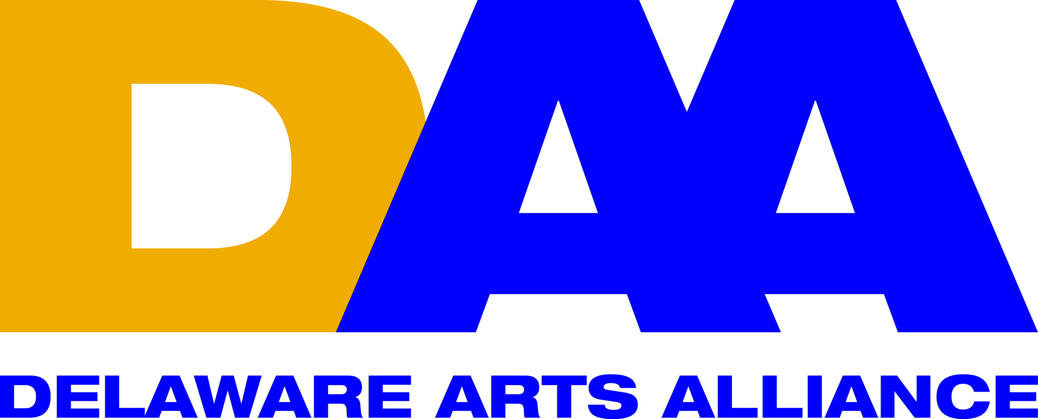 FOR IMMEDIATE RELEASE August 17, 2016
CONTACT: Lynn Calder
lcalder@DelawareArtsAlliance.org
(302) 468-4841

Delaware Arts Alliance announces launch of the 2016 Election Year DAA Voter Guide

Wilmington, DE (August 17, 2016) -- Delaware Arts Alliance (DAA) Executive Director Dr. Guillermina Gonzalez announced the launch of the 2016 DAA Voter Guide on its website (http://www.delawareartsalliance.org/candidate-questionnaire). The Voter Guide shares positions on the arts, arts policy, arts education and the impact of the arts on Delaware’s economy from candidates running for political office in the 2016 federal and state elections. DAA created the 2016 DAA Voter Guide to provide voters in Delaware with a tool to educate citizens about candidates’ positions on the arts and arts education so that they can make informed decisions at the voting booth.

The Voter Guide was created from survey results on the arts from candidates running for political offices in Kent, New Castle and Sussex Counties as well as federal and state offices. In May 2016, Delaware Arts Alliance emailed a survey to all candidates in the upcoming Delaware state and federal elections (for whom valid email addresses could be obtained). Candidates were asked to state their positions on various legislative matters as they relate to the arts and arts education in Delaware. Presented in the 2016 DAA Voter Guide are all of the responses received as of June 2016.

Dr. Gonzalez commented on the importance of the guide, “The 2016 DAA Voter Guide is a vital handbook for voters in the 2016 election so they can learn about the position of the candidate’s on the arts. DAA is committed to showing how the arts play a crucial role in Delaware’s economy and education—and that cultivating the arts should be a priority for political officials. We are very excited about our new tech-savvy Voter Guide, which allows citizens to easily access candidate’s responses to help as they make their voting decisions.”

The surveys were sent by VoterVoice, DAA’s advocacy software, which is a subscription-based advocacy software recommended and supported by Americans for the Arts (AFTA) for state alliances to enhance their reach at the federal, state, and local levels. 82 North, a technology company based in Centerville, DE that serves nonprofit organizations, created the on-line platform for the DAA 2016 Voter Guide.

Within the 2016 DAA Voter Guide, responses appear exactly as they were received, and were not edited. Candidate names, offices pursued, and party affiliations are based on how they appear in the Statewide General Candidate Listing in the Delaware.gov website as of June 2016. DAA does not endorse or support any candidate running for office and remains 100% neutral in all elections.

The Delaware Arts Alliance is the unifying voice for the arts and arts education throughout the state, advocating for the central role of the arts in advancing dynamic communities and a creative citizenry. DAA firmly believes that a strong creative culture enhances education, the economy, and civic life. Since its founding in 2009, the Alliance has made presentations to the Joint Finance Committee of the Delaware legislature, hosted speaking events, and organized advocacy programs throughout the state. For more information, please visit www.delawareartsalliance.org.

###

